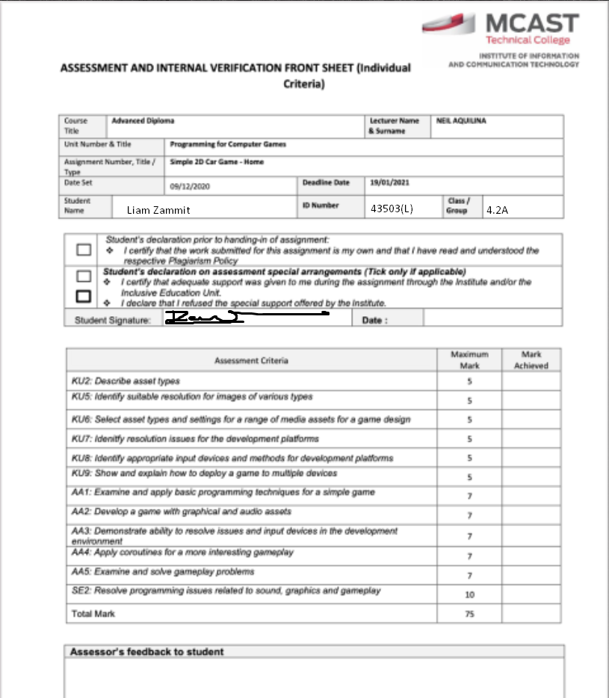

|  |  |
| --- | --- |
| **Test Case 1** |  |
| **Line Error** |  |
| **Error Explanation** | I didn’t put the GameOver scene into the build settings |
| **Error Correction** | I dragged the GameOver scene into the build settings |
| **Error**  **Correction**  **ScreenShot** |  |

|  |  |
| --- | --- |
| **Test Case 2** |  |
| **Line Error** |  |
| **Error Explanation** | The bullet didn’t have an audio clip in the field |
| **Error Correction** | I inserted an audio clip to the field |
| **Error**  **Correction**  **ScreenShot** |  |

|  |  |
| --- | --- |
| **Test Case 3** |  |
| **Line Error** |  |
| **Error Explanation** | The objectshooting script in one of the prefabs didn’t have a game object in laser prefab |
| **Error Correction** | I added the laser prefab in the field |
| **Error**  **Correction**  **ScreenShot** |  |

|  |  |
| --- | --- |
| **Test Case 4** |  |
| **Line Error** |  |
| **Error Explanation** | One of the prefabs required a game object for Death VFX |
| **Error Correction** | I added the game object to the prefab |
| **Error**  **Correction**  **ScreenShot** |  |

|  |  |
| --- | --- |
| **Test Case 5** |  |
| **Line Error** |  |
| **Error Explanation** | I forgot to type the semi colon |
| **Error Correction** | I typed in the semi colon |
| **Error**  **Correction**  **ScreenShot** |  |

|  |  |
| --- | --- |
| **Test Case 6** |  |
| **Line Error** |  |
| **Error Explanation** | health was written wrong |
| **Error Correction** | I retyped health by having a capital letter |
| **Error**  **Correction**  **ScreenShot** |  |

|  |  |
| --- | --- |
| **Test Case 7** |  |
| **Line Error** |  |
| **Error Explanation** | Health was meant to be int not float |
| **Error Correction** | I changed Float into Int |
| **Error**  **Correction**  **ScreenShot** |  |

|  |  |
| --- | --- |
| **Test Case 8** |  |
| **Line Error** |  |
| **Error Explanation** | The program didn’t let me insert ui text |
| **Error Correction** | I added UnityEngine.UI; |
| **Error**  **Correction**  **ScreenShot** |  |

|  |  |
| --- | --- |
| **Test Case 9** |  |
| **Line Error** |  |
| **Error Explanation** | Player script had a typo. |
| **Error Correction** | I corrected it by typing Player instead of player |
| **Error**  **Correction**  **ScreenShot** |  |

|  |  |
| --- | --- |
| **Test Case 10** |  |
| **Line Error** |  |
| **Error Explanation** | I had a missing curly bracket at the end of the script |
| **Error Correction** | I added the curly bracket |
| **Error**  **Correction**  **ScreenShot** |  |

|  |  |
| --- | --- |
| **Test Case 11** |  |
| **Line Error** |  |
| **Error Explanation** | No scene was being called to be loaded |
| **Error Correction** | I added the number of the scene to load |
| **Error**  **Correction**  **ScreenShot** |  |

|  |  |
| --- | --- |
| **Test Case 12** |  |
| **Line Error** |  |
| **Error Explanation** | It couldn’t load any scenes without scene management |
| **Error Correction** | I added unityengine.scenemanagement; |
| **Error**  **Correction**  **ScreenShot** |  |

|  |  |
| --- | --- |
| **Test Case 13** |  |
| **Line Error** |  |
| **Error Explanation** | GameObject is a type so I couldn’t use it |
| **Error Correction** | I changed GameObject into gameObject so it could work |
| **Error**  **Correction**  **ScreenShot** |  |

|  |  |
| --- | --- |
| **Test Case 14** |  |
| **Line Error** |  |
| **Error Explanation** | Win Scene wasn’t added in Build Settings |
| **Error Correction** | I added Win scene in the Build Settings |
| **Error**  **Correction**  **ScreenShot** |  |